# JS Advanced: Exam Preparation

Problems for exam preparation for the [“JavaScript Advanced” course @ SoftUni](https://softuni.bg/courses/javascript-advanced). Submit your solutions in the SoftUni judge system at <https://judge.softuni.bg/Contests/352/>.

## Summary

You will be given an HTML document, containing an article and a button. Some parts of the text will be highlighted with a <strong> tag. Write a JS function that receives a **selector** to the **button** and attaches an **event** to it. The event **executes a function** that finds all **highlighted** parts of the text and places them in a **summary after** the original **article**. The article will **always** be inside a div with **ID** **'content'**.

The **summary** should be inside a div with **ID** '**summary'**, appended after the original article (at the end of its parent). The first element inside the div is a heading (<h2>) with the text **'Summary'**. The second element is a paragraph (<p>), inside which are all the extracted parts from the original article. Note that you **only** need the text **without** the <strong> tags that originally surround it. See the example for more details.

### Examples

|  |
| --- |
| Sample Input |
| <**div class="holder"**>  <**input type="button" id="generate" value="Generate Summary"**/>  <**div id="content"**>  <**p**><**strong**>Important text. </**strong**>Not too important. <**strong**>Also useful info.</**strong**></**p**>  </**div**> </**div**> |
| Sample Output |
| <**div class="holder"**>  <**input type="button" id="generate" value="Generate Summary"**/>  <**div id="content"**>  …  </**div**>  <**div id="summary"**>  <**h2**>Summary</**h2**>  <**p**>Important text. Also useful info.</**p**>  </**div**>  </**div**> |

|  |
| --- |
| Sample Input |
| <**div class="wrapper"**>  <**div id="content"**>  <**p**><**strong**>The Theodor Pallady Museum </**strong**>is a museum situated in one of the oldest surviving merchant houses in Bucharest, Romania. It <**strong**>includes many works by the </**strong**>well-known Romanian <**strong**>painter Theodor Pallady</**strong**>, as well as a number of European and Oriental furniture pieces.</**p**>  </**div**>  <**input type="button" id="generate" value="Generate Summary"**/> </**div**> |
| Sample Output |
| <**div class="wrapper"**>  <**div id="content"**>  …  </**div**>  <**input type="button" id="generate" value="Generate Summary"**/>  <**div id="summary"**>  <**h2**>Summary</**h2**>  <**p**>The Theodor Pallady Museum includes many works by the painter Theodor Pallady</**p**>  </**div**>  </**div**> |

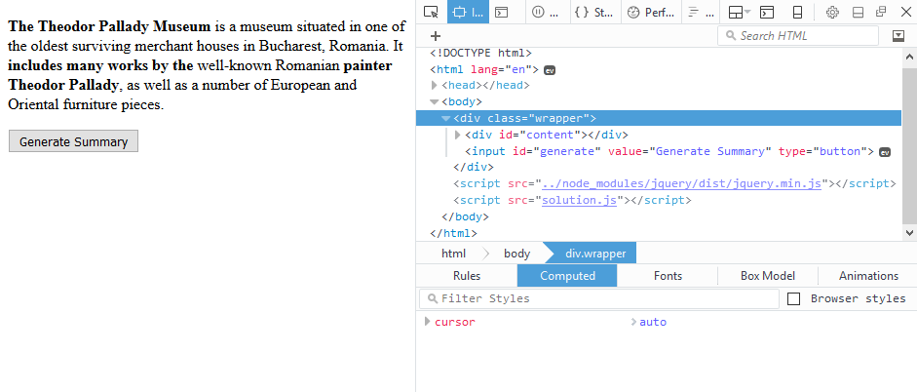

↓

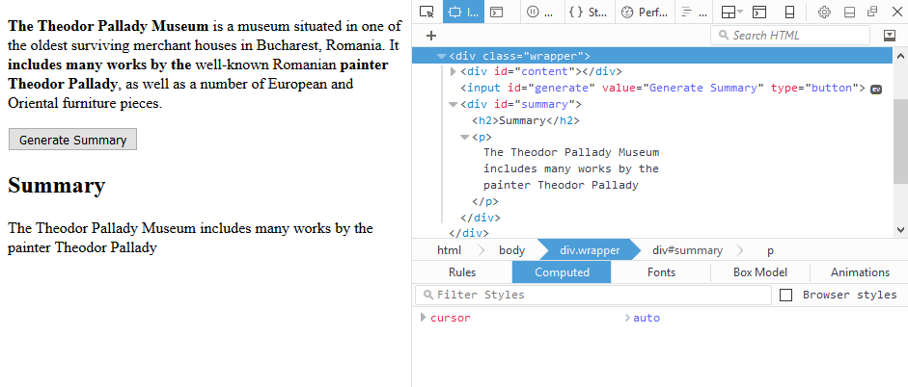

### Note

Submit your code using the **DOM unit tests** Judge strategy.